Build Lean and Secure Docker Images

What Matters (production view)

Problem | Business impact
1 GB images | Slow deployments, slow autoscaling, higher registry and network cost
Running as root | A single app bug can become full control of the container
Secrets inside images | Anyone who can pull the image can steal the key
Slow builds | Developers wait, CI minutes cost money
Unknown vulnerabilities | Audit failures and breaches

Pre-session pulls (do on good Wi-Fi):
docker pull python:3.12
docker pull python:3.12-slim
docker pull golang:1.22
docker pull aquasec/trivy:latest

Golang:1.22 - this is a go programming language runtime image.
aquasec/trivy - this image is a containing trivy tool that is used for scanning docker images for vulnerabilities.

Activity : Plz Observe the SIZE OF python:3.12 & python:3.12-slim [ reply in chat ]

Demo: Python Product API, single-stage vs multi-stage

Objective: Deploy a Flask using python:3.12 & Python:3.12-slim,
We shall also observe single stage build vs Multi Stage Build.

- Launch VS CODE and Select a Folder of your Choice.
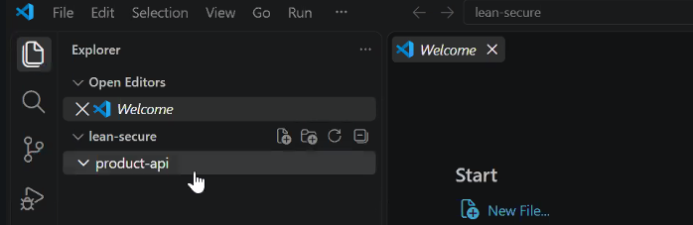

- Create a new file App.py and paste the code below:

from flask import Flask, jsonify

app = Flask(__name__)

PRODUCTS = [
{"id": 1, "name": "Laptop Stand", "price": 1499},
{"id": 2, "name": "USB-C Hub", "price": 2299},
]

@app.get("/health")
def health():
return {"status": "ok"}

@app.get("/products")
def products():
return jsonify(PRODUCTS)

-Create requirements.txt:
flask==3.0.3
gunicorn==22.0.0

- Create Dockerfile.single:
[ this is single stage file ]

FROM python:3.12
WORKDIR /app
COPY . .
RUN pip install -r requirements.txt
CMD ["gunicorn", "-b", "0.0.0.0:8000", "app:app"]

- Create Dockerfile.multi
# ---------- Stage 1: builder ----------
FROM python:3.12-slim AS builder
WORKDIR /build
COPY requirements.txt .
RUN pip install --no-cache-dir --prefix=/install -r requirements.txt
# ---------- Stage 2: runtime ----------
FROM python:3.12-slim
WORKDIR /app
COPY --from=builder /install /usr/local
COPY app.py .
EXPOSE 8000
CMD ["gunicorn", "-b", "0.0.0.0:8000", "app:app"]

- Build the image

docker build -f Dockerfile.single -t shopease-api:single .
docker build -f Dockerfile.multi -t shopease-api:multi .
docker images shopease-api

2 Approaches used to Build Lean Images

1- Slim Base Image
2- Multi Stage Build

Demo : Go Inventory service from 800 MB to under 15 MB

- Under secure-lean directory create another directory inventory
- (make sure your terminal is also pointing to inventory directory)

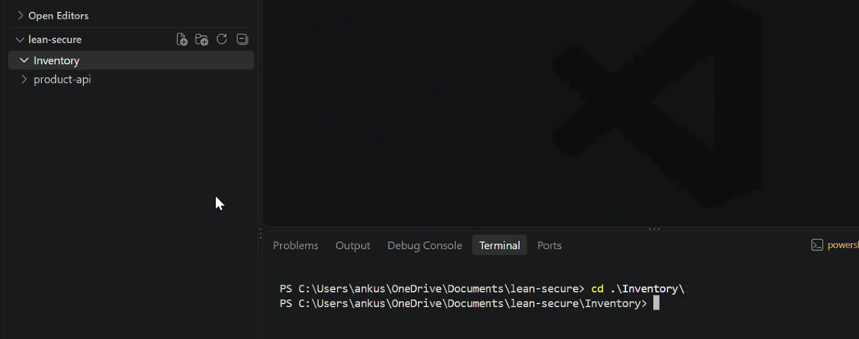

- Create a file go.mod
module inventory
go 1.22

- Create a file main.go
package main
import (
"fmt"
"log"
"net/http"
)
func main() {
http.HandleFunc("/health", func(w http.ResponseWriter, r *http.Request) {
fmt.Fprint(w, `{"status":"ok"}`)
})
http.HandleFunc("/stock", func(w http.ResponseWriter, r *http.Request) {
fmt.Fprint(w, `{"laptop-stand":42,"usb-c-hub":17}`)
})
log.Println("inventory listening on :8080")
log.Fatal(http.ListenAndServe(":8080", nil))
}

- Create Dockerfile:
FROM golang:1.22 AS build
WORKDIR /src
COPY go.mod main.go ./
RUN CGO_ENABLED=0 go build -ldflags="-s -w" -o /out/inventory .
FROM scratch
COPY --from=build /out/inventory /inventory
EXPOSE 8080
ENTRYPOINT ["/inventory"]

docker build -t shopease-inventory:1.0 .

- Test the Image by creating Container

docker run -d --name inv -p 8080:8080 shopease-inventory:1.0

Go to browser and type localhost:8080/stock

Ankush question: if i wish to run my webapp in a docker container and create image how do i do it.

1- download base image(OS+Runtime)
2- Create a Container
3- Deploy/Run/Test your APP & Required third party app like git.
4- Commit the Container(docker commit ….) - this creates an image out of Running container like snapshot
5-push the image onto dockerhub.

Image Hardening

Building Secure Images

The hardening checklist (the "Ten Rules")
- Minimal base image: slim, alpine, or distroless. Less software means fewer vulnerabilities.
- Pin versions: use python:3.12-slim, never latest. Experts can also pin the digest (@sha256:...) for exact repeatability.
- Run as non-root: add USER app. Root inside a container is dangerous if the app is compromised.
- Install only what you need: no curl, vim, git in production images.
- Read-only filesystem at runtime: --read-only stops attackers writing tools or changing files.
- Drop Linux capabilities: --cap-drop ALL, add back only what is required.
- No privilege escalation: --security-opt no-new-privileges:true.
- Limit resources: --memory, --cpus, --pids-limit stop one container starving the host.
- Scan images: Trivy or Docker Scout, in CI, on every build.
- Add a HEALTHCHECK so orchestrators know when the app is truly healthy.

Demo: Harden the Product API image

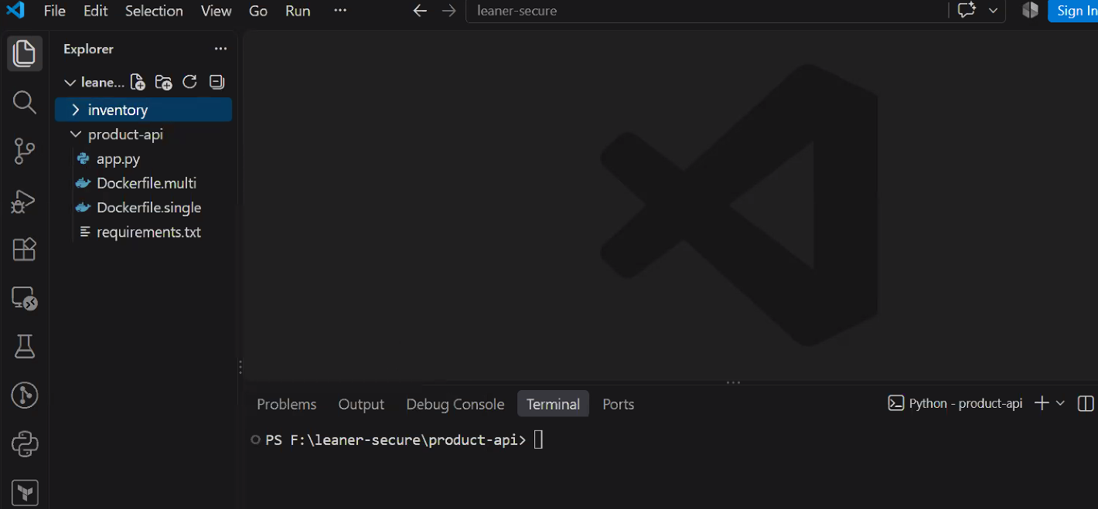

- Create a new file Dockerfile.hardened
FROM python:3.12-slim AS builder
WORKDIR /build
COPY requirements.txt .
RUN pip install --no-cache-dir --prefix=/install -r requirements.txt
FROM python:3.12-slim
ENV PYTHONDONTWRITEBYTECODE=1 \
PYTHONUNBUFFERED=1
RUN groupadd --system app && useradd --system --gid app --no-create-home app
WORKDIR /app
COPY --from=builder /install /usr/local
COPY --chown=app:app app.py .
USER app
EXPOSE 8000
HEALTHCHECK --interval=15s --timeout=3s --retries=3 \
CMD python -c "import urllib.request; urllib.request.urlopen('http://localhost:8000/health')" || exit 1
CMD ["gunicorn", "-b", "0.0.0.0:8000", "app:app"]

PYTHONDONTWRITEBYTECODE=1
Prevents Python from writing .pyc bytecode files when importing modules.

PYTHONUNBUFFERED=1
Disables buffering of Python's standard output and standard error streams.

docker build -f Dockerfile.hardened -t shopease-api:hardened .

Create 2 Containers using single & hardened

docker run -d --name api-single -p 8002:8000 shopease-api:single
docker run -d --name api-hardened -p 8000:8000 shopease-api:hardened

docker exec api-single whoami

docker exec api-hardened whoami

docker rm -f api-hardened

docker run -d --name api-locked -p 8000:8000 \
--read-only --tmpfs /tmp \
--cap-drop ALL \
--security-opt no-new-privileges:true \
--memory 256m --cpus 0.5 --pids-limit 100 \
shopease-api:hardened

docker run -d --name api-locked -p 8000:8000 --read-only --tmpfs /tmp --cap-drop ALL --security-opt no-new-privileges:true --memory 256m --cpus 0.5 --pids-limit 100 shopease-api:hardened

Testing Readonly Files System

docker exec api-locked touch /app/hacked.txt

Security Scan for vulnerabilities

docker run --rm -v /var/run/docker.sock:/var/run/docker.sock aquasec/trivy:latest image --severity HIGH,CRITICAL shopease-api:single

docker run --rm -v /var/run/docker.sock:/var/run/docker.sock aquasec/trivy:latest image --severity HIGH,CRITICAL shopease-api:hardened

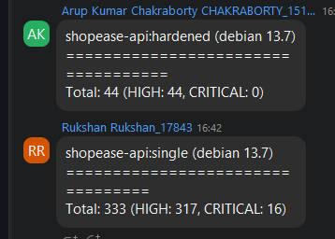

Shopease:Single Scan
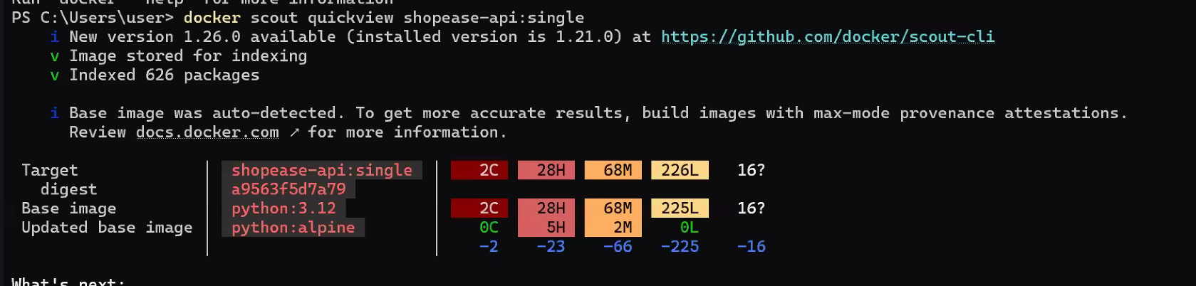

Shopease:Hardened Scan
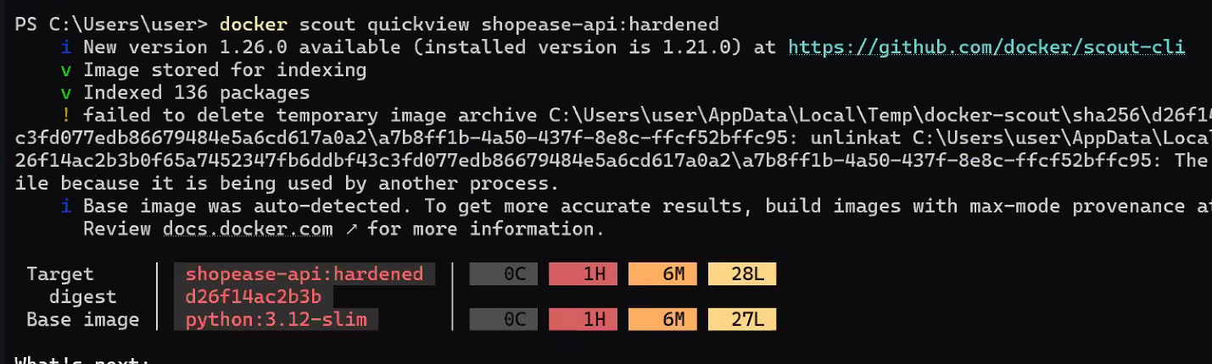

Hardened Trivy SCAN

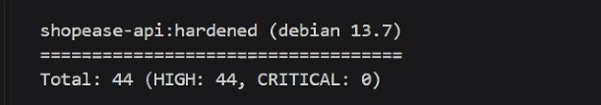
SingleTrivy Scan

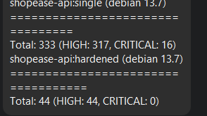

Working with SECRETS

Analogy: Never write the combination of a safe on the safe's door. A secret is anything that gives access: passwords, API keys, tokens, private keys, certificates. If it is inside the image, everyone who can pull the image owns the secret.

-

